Refer to the following information for the next two questions.

The sketch shows the shadow of your hand held in front of a white screen in a darkened room. The light source is red, so the screen looks red and the shadow looks black. Discuss with your partner the colors belonging in each part of the sketch.
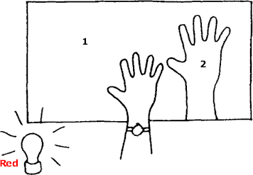

The color of region 1 on the diagram is

blue | cyan | green | magenta | red | yellow | black | white

- The color of region 2 on the diagram is

blue | cyan | green | magenta | red | yellow | black | white

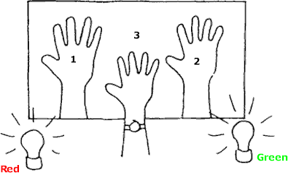
Refer to the following information for the next two questions.

The sketch shows the shadow of your hand held in front of a white screen in a darkened room. The light sources are red and green. Discuss with your partner the colors belonging in each part of the sketch

The color of region 2 on the diagram is

blue | cyan | green | magenta | red | yellow | black | white

- The color of region 3 on the diagram is

blue | cyan | green | magenta | red | yellow | black | white

Refer to the following information for the next two questions.

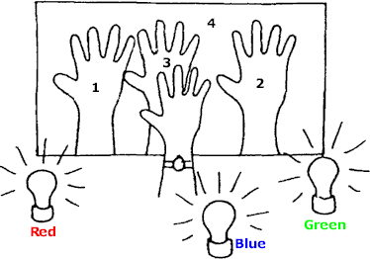
The sketch shows the shadow of your hand held in front of a white screen in a darkened room. The light sources are blue, green and red. Discuss with your partner the colors belonging in each part of the sketch
- The color of region 1 on the diagram is

blue | cyan | green | magenta | red | yellow | black | white

The color of region 2 on the diagram is

blue | cyan | green | magenta | red | yellow | black | white

- The color of region 3 on the diagram is

blue | cyan | green | magenta | red | yellow | black | white

The color of region 4 on the diagram is

blue | cyan | green | magenta | red | yellow | black | white

Refer to the following information for the next seven questions.

The lamps are placed closer together so the shadows overlap. Discuss with your partner the colors belonging in each part of the sketch.
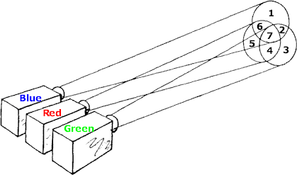
- The color of region 1 on the diagram is

blue | cyan | green | magenta | red | yellow | black | white

The color of region 2 on the diagram is

blue | cyan | green | magenta | red | yellow | black | white

- The color of region 3 on the diagram is

blue | cyan | green | magenta | red | yellow | black | white

The color of region 4 on the diagram is

blue | cyan | green | magenta | red | yellow | black | white

- The color of region 5 on the diagram is

blue | cyan | green | magenta | red | yellow | black | white

- The color of region 6 on the diagram is

blue | cyan | green | magenta | red | yellow | black | white

What do light filters filter out?
- In a department-store window display, white light passing through a red filter falls on cyan- and yellow-colored objects. What colors are seen by someone looking at the display through the store window?

How do different-colored spotlights influence the appearance of a performer’s clothes, for example, a red spotlight on a performer in a dark blue suit?
What color spotlight would you use if you wanted to make the performer really stand out?

What color would a green chalkboard appear to be when viewed through yellow sunglasses? How about when viewed through rose-colored (red) glasses?
If the chalkboard had writing on it in white-chalk, what color would the writing appear to be in the cases mentioned above?

How would the American flag appear when illuminated with
  - red light.

blue light.
  - green light.

Could you ignite a piece of paper with a magnifying glass and sunlight more quickly if the paper were white or black? Explain.
- Why is the inside of a camera black?

Why do fluorescent lamps tend to enhance blue clothing more than incandescent lamps?

- Two complementary colors produce white, but if a colored light from a spotlight falls on an object with its complementary color, it appears black. Why?

Why does a white piece of paper appear white, red, blue, of the color of whatever type of light that it illuminates?

- By which process of color production could red and cyan (purplish-red) colors be combined to get white?

Can white be obtained by the subtractive method of color production? Explain.

- Is color TV based on the additive or subtractive method of color production? Explain.

A painter mixes paints with the primary pigments of . What are the colors of the resulting paint mixtures?
- Yellow and blue

Blue and red
- Clouds generally appear white, but nimbus clouds that threaten or produce rain appear dark. Why is this?

Why is the sky blue in the daytime?

- Why does the sun generally appear yellowish-orange at sunset?

- REVIEW: A person is driving north in a car at a constant speed. A police officer is driving south toward him at a constant speed. The police officer uses a radar unit to measure the speed of the person’s car. The radar unit sends out waves of a certain frequency toward the person’s car. The waves reflect off the person’s car and travel back to the radar unit in the police car.

What happens to the frequency of the waves detected by the radar unit?

A. The frequency is lower as the person’s car approaches.
B. The frequency is higher as the person’s car approaches.
C. The frequency remains the same but with increased energy as the person’s car approaches.
D. The frequency remains the same but with decreased energy as the person’s car approaches.
- REVIEW: Electromagnetic waves with low frequencies have been used for long-distance underwater communication. These waves most likely belong to which of the following parts of the electromagnetic spectrum?

A. gamma rays | B. infrared waves | C. radio waves | D. x-rays
- REVIEW: During a thunderstorm, which of the following travels at a speed closest to 3.00 x 10⁸ m/s?

A. wind from the  storm | B. sound from the thunder | C. light from the lightning | D. rain from the storm clouds
- REVIEW: Which of the following properties is the same for all electromagnetic waves in a vacuum?

A. amplitude | B. frequency | C. speed | D. wavelength
- REVIEW: When a student listens to music, sound waves propagate from the speaker to her ear. Which of the following is a physical description of this process?

A. Particles produced at the speaker move to the student’s ear.
B. Energy is transported from the speaker to the student’s ear.
C. Material is transferred from the speaker to the student’s ear.
D. Clusters of air molecules are sent from the speaker to the student’s ear.

REVIEW: Which of the following statements best describes the visible spectrum of light as seen by the human eye?

A. The lowest frequency appears red, and the highest frequency appears violet.
B. The lowest frequency appears red, and the highest frequency appears yellow.
C. The lowest frequency appears green, and the highest frequency appears violet.
D. The lowest frequency appears green, and the highest frequency appears yellow.

- REVIEW: To locate objects in their environments, bats in flight and porpoises under water both use ultrasound waves with frequencies that are beyond human hearing. These animals produce an ultrasonic wave and then detect echoes from nearby objects.

If a porpoise and a bat both produce ultrasonic waves when they are 16 m from an object, which animal would hear its echo first and why?

A. The bat would hear its echo first because sound travels faster in air than in water.
B. The porpoise would hear its echo first because sound travels faster in water than in air.
C. The bat would hear its echo first because the amplitude of sound waves is greater in air than in water.
D. The porpoise would hear its echo first because the amplitude of sound waves is greater in water than in air.
- REVIEW: Electromagnetic waves of various frequencies reach Earth from distant parts of the universe. Which of the following can be inferred from this?

A. The wavelengths must be very short.
B. A single material must fill all of space.
C. These waves can travel without a medium.
D. The speed of these waves is 300,000,000 m/s.

- REVIEW: The speed of sound in a particular gas is 900 m/s. A sound wave propagating in this material has a wavelength of 15 m. What is the frequency of this sound?

A. 30 Hz | B. 60 Hz | C. 6,800 Hz | D. 13,500 Hz

- REVIEW: Which of the following statements best describes an electromagnetic wave with a long wavelength?

A. It has a low frequency and can travel in a vacuum.
B. It has a high frequency and can travel in a vacuum.
C. It has a low frequency and can only travel in a medium.
D. It has a high frequency and can only travel in a medium.
- REVIEW: In an electromagnetic wave, an electric field exists perpendicular to a magnetic field, and both fields are perpendicular to the direction of travel of the wave. These characteristics indicate that an electromagnetic wave is which of the following wave types?

A. gravitational | B. longitudinal | C. mechanical | D. transverse
- Which of the following is an example of an electromagnetic wave?

A. a radio wave
B. a water wave
C. the oscillation of a spring
D. the vibration of a violin string

